Termwork 1

Name: Nehal Malu

USN: 2GI20CS071

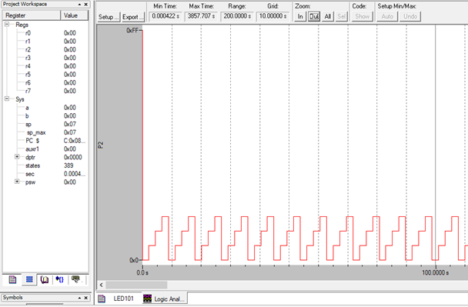

Hardware Delay

Software Delay